1. User administration and roles, where are the roles managed? How are these working now?

>>>For now You can just add and update roles. When all other task finish we will discuss with you and assign which roles can access/see/update which task.

Please

keep in mind what should be done.

>>>Okay.

1. When adding an insured, the letters “sdadtubhj” always appear in the First Name, please delete this text

>>>We don’t see anything like this may be its comes as we are editing while you testing. Please check this again if its still appear please send us an screenshot/video.

I save the first insured like Main Insured and then show Dependent. When I add a new insured start in order 2 no 1.

>>>Insured order fixed. Regarding First Name we checked in all browser don’t see anything like this still made some changes which may create that issue. It should be okay now. Please test again and let us know.

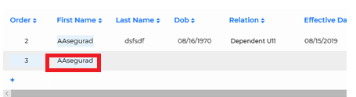

Ok

1. The field of effectiveness date of the insured must be left by default with the same of the policy.

>>>Done please check and confirm.

No, I add an insured and not put the effective date of the policy

>>>Please check now.

Ok

1. The insured's age is not being calculated correctly, it must be according to the insured's effective date, for example, he believes insured with DOB 8/17/1970, Effective Date 8/15/2019 comes out 49 years and according to the dates the person is still 48 years old, not 49.

>>>Done please check and confirm.

It’s not correct, the person has 49 the next day of the effective date, in effective date has 48 years yet

>>>Please check now.

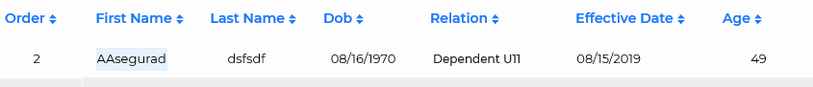

Ok

1. When saving a new policy and clicking on Save, I do not leave the data of the policy, I clean all the records and I have to go back to the beginning to be able to enter the created policy. You must stay in the same policy, because say Save, not Save and exit.

>>>Done please check and confirm.

ok

1. The DOB of policyholder 1 of policy 1SN19-00030 does not keep it, I leave the data empty

>>>We changed the value to ‘08/25/2009’ and its keeping the value.

It’ not working the part of insured correctly. I save the policy, then close and enter agein and now show this information,

Now show oreder , before sho order 2, the DOB disappeared

>>>Please check now.

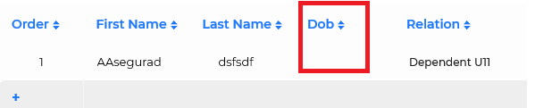

Ok

1. When browsing through the options, and entering the policy appears like this, the corresponding fields do not appear

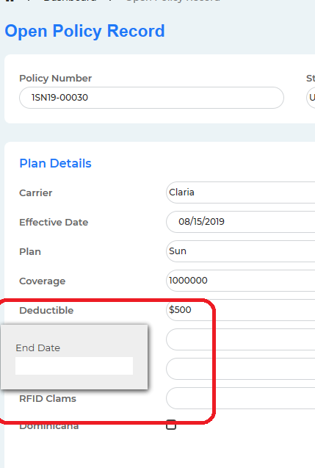

>>>You see this because we are editing while you testing. Please check this again it shouldn’t appear now.

At the moment it’s ok

1. When saving a rate up, the insured rate up option is re-entered and does not appear in the list of rate ups.

>>>Rate up now showing curren trate up for insured. We asume for single insured there is only 1/single rate up. Isn’ this correct? Did you mean something else? Where do you want to see the rateup lists. Please send us some screenshot/video if posible.

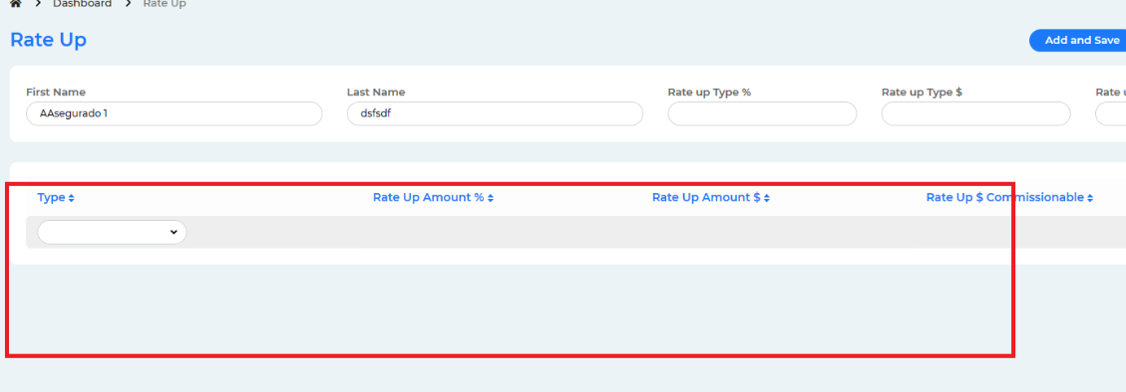

In the red box, the system must to show the rate ups of the insured.

I click in add and save and the system closed the session, do sign out.

>>>Please check now.

Ok

1. When adding a rider, the rider's number is given by the system, the name of the insured to which you select to add the rider must appear in name. In the print option nothing comes out, the status shows a 0 and not the status that was set.



>>>Done please check and confirm.

The rider must to contain the policy number like this 1EL08-01307RID70554.

>>>Please check now.

I click in the rider in the button close, and does nothing

>>>Please check now.

Ok

1. Approval Sheet, add only one and show 2 times

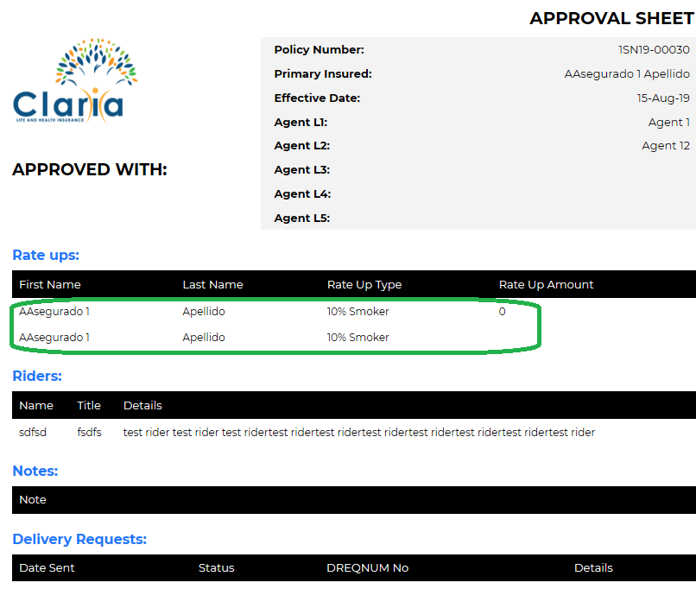

>>>Done please check and confirm.

Ok

Not show all info, the policy 1SR19-00044 has a note and not show in Apprval Sheet

>>>I see there is no note when I opened the policy now I add one ‘Test note’ and showing in the approval sheet. Please check again. Make sure you saved policy after adding note.

, has 2 rate ups and only show 1

>>>Fixed now earlier we though rate up was single that is why this issue come.

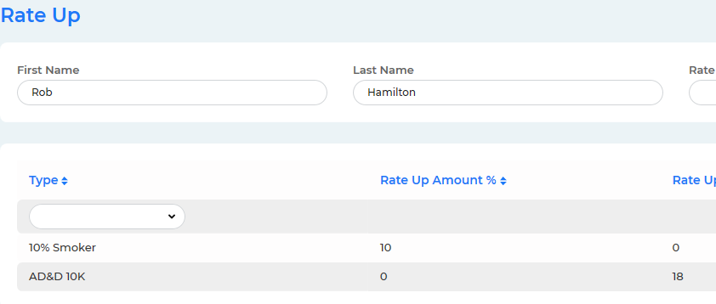

ok

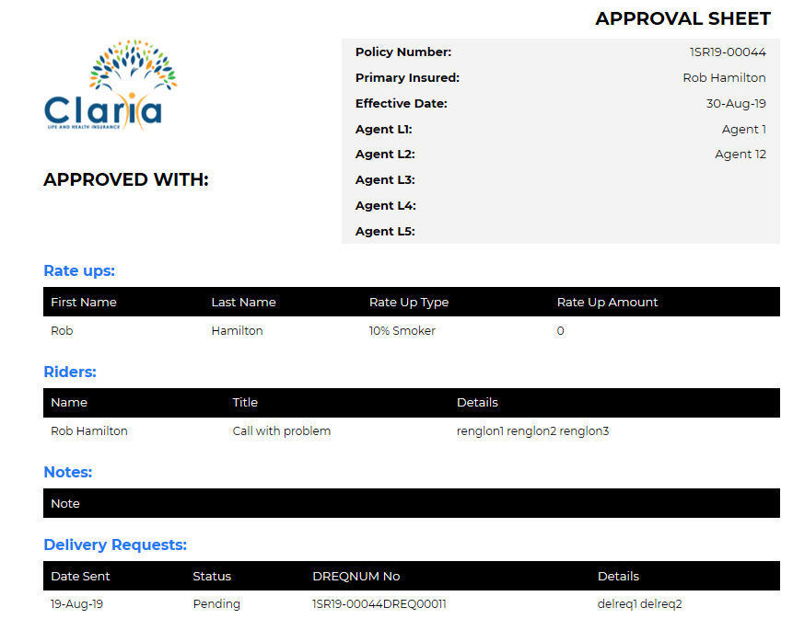

1. In the lower part of the policy the insured section appears again and some fields that I do not know to which they correspond

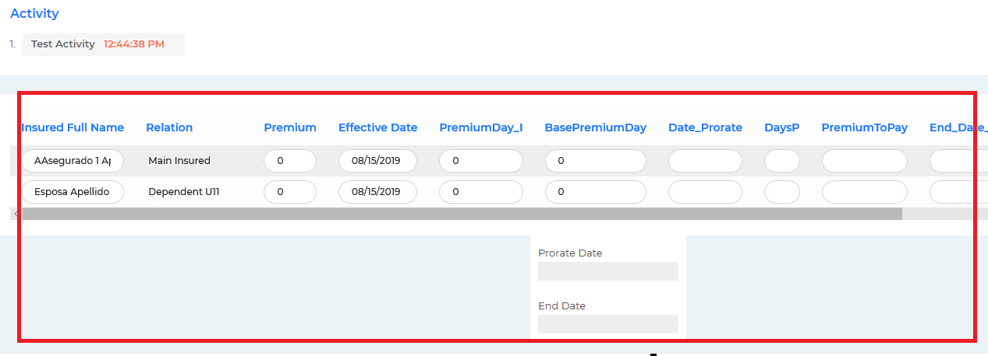

>>>You see this because we are editing while you testing. Please check this again it shouldn’t appear now.

ok

1. Delivery request no se conserva como se guardo

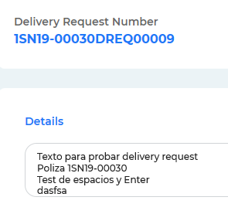

It is saved with spaces and when printed it shows everything in a single line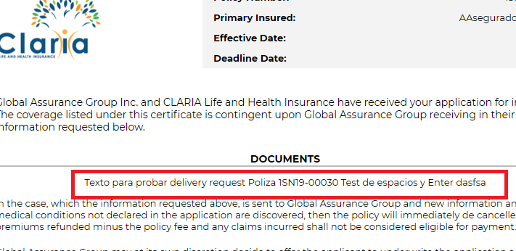

>>>Done please check and confirm.

ok

1. By adding a user and selecting the word “sdadtubhj” I change all user names

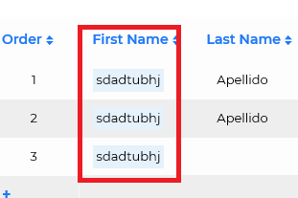

>>>Again you see this because we are editing while you testing. Please check this again if its still appear please send us an screenshot/video.

When I add the other insure I click in + and put the same name that the first insured automatically, I don’t write the name the system put.

>>>Please check again we made some changes it should be okay now please let us know if not. Please clear your browser cache before.



Ok

1. According to the request, the rider maternity should not appear in the insured only at rate ups

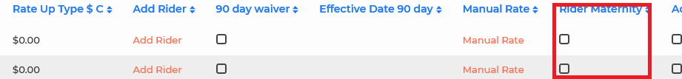

>>>We have removed this from insured area.

OK

1. The Calculate Premiums option was selected and did nothing

>>>You need to select the zone World/Maico/Srilanka etc. For policy ‘1SN19-00030’ we have selected zone world now its calculating premium. URL: http://bdmonster.com/module-insurance-system/main/health-edit/30

What premiums do you put in the system, the rates that I sent? For example I click in calculate premium for !SK19-00040 in the table the rate is $4330 and has a rate up 10% over-weight so is $433 more. So is $4763. And show $4524.85, Additionally if I enter ti manual rate show the info empty. The system must to show the base premium and premium.

>>>Please check now.

The premium is not working the insured Rob Hamilton has Rate ups and it’s not in the premium

>>> I have clicked the ‘Calculate Premium’ link and the premium has been calculated according to the rate ups and other details. Please check it. Did you calculate the premium after adding the rate ups by clicking the ‘Calculate Premium’ link? Please make sure to calculate the premium after adding any rate ups or any other data that is related to premium calculation.

<http://bdmonster.com/module-insurance-system/main/health-edit/44>

It’s not working

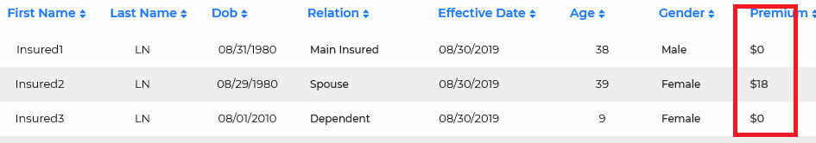

1. A note was added to the policy, I save it and then it did not appear.

>>>We have added a note ‘Test New Note save’ its appearing everywhere accordingly for policy ‘1SN19-00030’. URL: <http://bdmonster.com/module-insurance-system/main/health-edit/30>

I test again, it’s ok

It’s happen again I put a note, and the it’s not in the policy

>>>I see policy note is saving. Please make a screen capture video if possible where you adding note and not showing.

It’s working the problem is sometimes working and other not. I hope this time is working always.

1. Manual rate must appear the name of the selected insured, when it is stored it must remain in the prermium and premium base, it does not show it

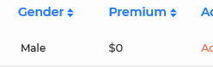

It’s empty

>>>Please check now.

ok

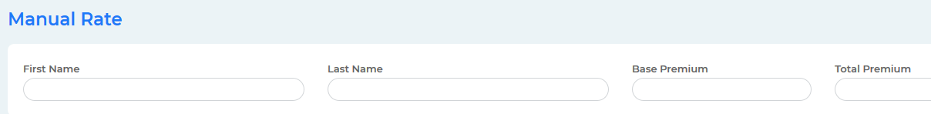

I can’t verify this until the calculate premium is working

1. Print booklet and id card, please with templates

>>>We are working with this.

It’s not working

>>>We agree earlier that we will do it in milestone 3 and delete policy in milestone 2. Anyway we are working on it.

I have not accepted this change, I need this to work in milestone 2.

1. Cancellation Notice put he footer



>>>Done please check and confirm.

It’s ok, please put in bold

>>>Please check now.

I don’t put any cancellation date and show a date

>>>Fixed now please check.



ok